"The Ultimate Andaman Island Experience”
(4N/5D)

Discover the tropical paradise of the Andaman Islands on this unforgettable 5 Days / 4 Nights holiday. Explore the historic Cellular Jail and witness its captivating Light & Sound Show in Port Blair. Cruise across the turquoise waters to Havelock Island (Swaraj Dweep), home to the world-famous Radhanagar Beach. Experience the vibrant underwater world with a complimentary snorkelling session at Elephant Beach. Relax on the serene shores of Kalapathar Beach, known for its crystal-clear waters and scenic beauty.

From pristine white-sand beaches to breathtaking sunsets and thrilling island adventures, every moment promises a memorable experience. Perfect for couples, families, honeymooners, and adventure seekers, this itinerary offers the ideal blend of relaxation, nature, and marine exploration. Leave with unforgettable memories of one of India's most spectacular island destinations.

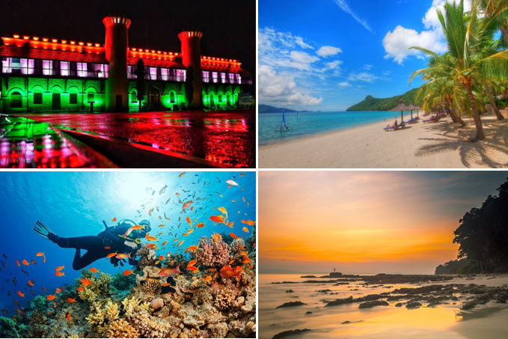
We wish you a happy, safe and unforgettable journey with us

Detailed Itinerary
Day 1: Arrival in Port Blair | Corbyn's Cove Beach & Cellular Jail Light & Sound Show
Upon arrival at Veer Savarkar International Airport, Port Blair, meet our representative and transfer to your hotel. After checking-in and some time to relax, visit the scenic Corbyn's Cove Beach, known for its serene shoreline and picturesque coastal views. In the evening, witness the captivating Light & Sound Show at Cellular Jail, where the inspiring story of India's freedom struggle comes alive through dramatic narration and visual effects. Return to the hotel for an overnight stay in Port Blair.
Day 2: Port Blair – Havelock Island | Radhanagar Beach
After breakfast, transfer to the jetty to board a cruise to Havelock Island (Swaraj Dweep), one of the most beautiful islands in the Andaman archipelago. Upon arrival, meet our representative and transfer to your resort. Later, visit the world-famous Radhanagar Beach, consistently ranked among Asia's finest beaches, renowned for its pristine white sands, turquoise waters, and spectacular sunset views. Spend the evening soaking in the natural beauty before returning to the resort for an overnight stay in Havelock.
Day 3: Elephant Beach Excursion | Snorkelling Experience
After breakfast, proceed by boat to Elephant Beach, one of Havelock's most popular destinations for water activities and vibrant coral reefs. Enjoy a complimentary snorkelling session under the guidance of experienced instructors and explore the colorful underwater world (subject to weather and local authority guidelines). Spend time relaxing on the beach or indulge in optional water sports at an additional cost. Later, return by boat and transfer to your resort for an overnight stay in Havelock.
Day 4: Kalapathar Beach – Port Blair
After breakfast, visit the peaceful Kalapathar Beach, famous for its crystal-clear waters, black rocks, and tranquil surroundings, making it a perfect spot for relaxation and photography. Later, transfer to the jetty to board your cruise back to Port Blair. Upon arrival, meet our representative and transfer to your hotel. Spend the evening at leisure before an overnight stay in Port Blair.
Day 5: Departure from Port Blair
After breakfast, check out from the hotel and transfer to Veer Savarkar International Airport for your onward journey. Depart with unforgettable memories of the Andaman Islands, its pristine beaches, crystal-clear waters, vibrant marine life, and serene island experiences. We wish you a safe journey and hope to welcome you again for another memorable holiday.
Tour ends with unforgettable memories
Destination/Nights | 3* Hotel Name
Port Blair /02N
Havelock /02N
HOTELS DETAILS:

Package Cost:

3★ Hotels: Rs. per person (Based on 6 guests – Double Sharing Basis)

Inclusion: -
- Daily breakfast except on day of arrival.
- Meet and greet service at airport.
- All sightseeing by Private AC Vehicle at all the islands.
- All cabs on all islands are pointed to point 03 Nights in Accommodation in hotel.
- Transfer to Port Blair / Havelock Island/Neil Island in Private Catamaran Nautika - Luxury Class / Makruzz - Premium Class (Any upgrade of seats will be chargeable and can be communicated at the time of booking)
- Ferry Sailing timings from Port Blair to Havelock from 7:30 AM / 8 AM / 8:30 AM as per availability
- Full-day tour with all transfers including airport pick-up and drop. All Transfers and S.S tours by AC Vehicle
- Personal Tour Coordinators for one Point of Contact.
- The field executive will provide travel assistance at all the major entry and exit points (Airport, Jetty, Jail, Water sports complex, Havelock, Neil, etc.).
- Complimentary Snorkeling session at Havelock

Exclusions: -
- 5% GST.
- Flight Tickets are not included.
- Guide & Extra meal not included or as per the inclusions given above.
- Vehicle not at disposal.
- Any personal expenses. Room service and special orders. Alcoholic and non-alcoholic beverages.
- Any expense arising due to unforeseen circumstances is not included.
- No extra pickup or drop included for lunch/sightseeing unless otherwise mentioned in the itinerary.

